|  |  |  |
| --- | --- | --- |
| 53.5 | 85 | 63 |
| Total | Possible | Your Mark % |

These are the colours I use in marking ...   
Incorrect answer/format/spelling  
Correct answer  
Comment or suggestion or warning  
Irrelevant or unnecessary or confusing or vague or repetitive or not part of the question

[You may have to turn on 'Track Changes/Show Markup'  
to see my comments in red. Bob 3063]  
  
///////////////Please keep your formatting simple and easy to read.

Avoid:

* Excessive bullets

* Text boxes

* Columns

* Centering

* Full Justification

* Right Justification

* Highlighting

* Coloured Text – I have changed your text from red to black. It’s easier to read. Please save red for your marker. Thanks. If this causes a problem, please let us know …

* Bold type

* Italics

* Underlining

* Large font sizes (use 12)

* Small font sizes (use 12)

These 'enhancements' usually make your work more difficult and confusing to read.

If you leave three blank lines between questions and one or two blank lines between parts of questions, your steps and answers will stand out clearly and will be easier to read, grade, and comment upon.

Your clean and clear presentation will also be more appealing to employers and enrollers.

Bob 3063

1. The development of MRI imaging technology is one useful spinoff of basic research into the structure of the atom. Research, however, is expensive. Many people argue that the high cost of research outweighs its potential benefits. Provide one argument for and one argument against increasing current funding for atomic-structure research. Use specific examples from this lesson in your answer to support each position.

For: It is impossible to put a price tag on human lives. The medical application of MRI imaging technology, X-rays, and others atomic structure related technologies have benefited countless people’s health conditions. Therefore, it is necessary to increase the findings for researching such subjects.

Against: The research and use of MRI are expensive. This means not everyone will have equal opportunity to have access to these expensive technologies. Funding should be prioritizing the less opportune people instead of researching.  
  
01 Atomic Structure Research

Arguments re increasing funding:

One Pro 3 mx ✓🗶🗶 see below …

One Con 3 mx ✓🗶🗶 ditto …

=== 1/6

Please read carefully. The question asks for comments on INCREASING CURRENT FUNDING INTO ATOMIC STRUCTURE RESEARCH.

The question does not ask for an explanation of MRI or a discussion of funding more MRI's or research into MRI's. MRI is cited as just one spinoff of basic atomic structure research.

You might want to broaden your research by looking at advances in nanotechnology, semiconductors, superconductors, nuclear waste transmutation, solar cells, cancer treatment, etc. ...

Please read the question carefully to discover the point you are aiming for, then get to the point clearly and briefly.

1. The emission spectrum of an unknown element contains two lines-one in the visible portion of the spectrum, and the other, ultraviolet. Based on the following figure and on what you have learned about Niels Bohr’s model of the atom, account for the difference in energy between these lines.

The difference in energy between the colors is the result of electrons jumping to higher orbit after absorbing energy from external source, and eventually returning to its original lower energy level, and thus emitting the energy it has absorbed.  
  
02 Emission Spectrum

UV has more energy than visible 1 mk 🗶 missing

Electron drops farther for UV 1 mk 🗶 missing

More energy emitted by greater fall 1 mk 🗶 missing

=== 0/3

Please clarify which is which, i.e. compare the amounts of energy producing visible or UV light. These amounts are related to the size of the electron transition, i.e. how far it has ‘fallen’ in the Bohr model.

1. a. Draw the energy-level diagram and write the electronic configuration for zirconium (element 40).

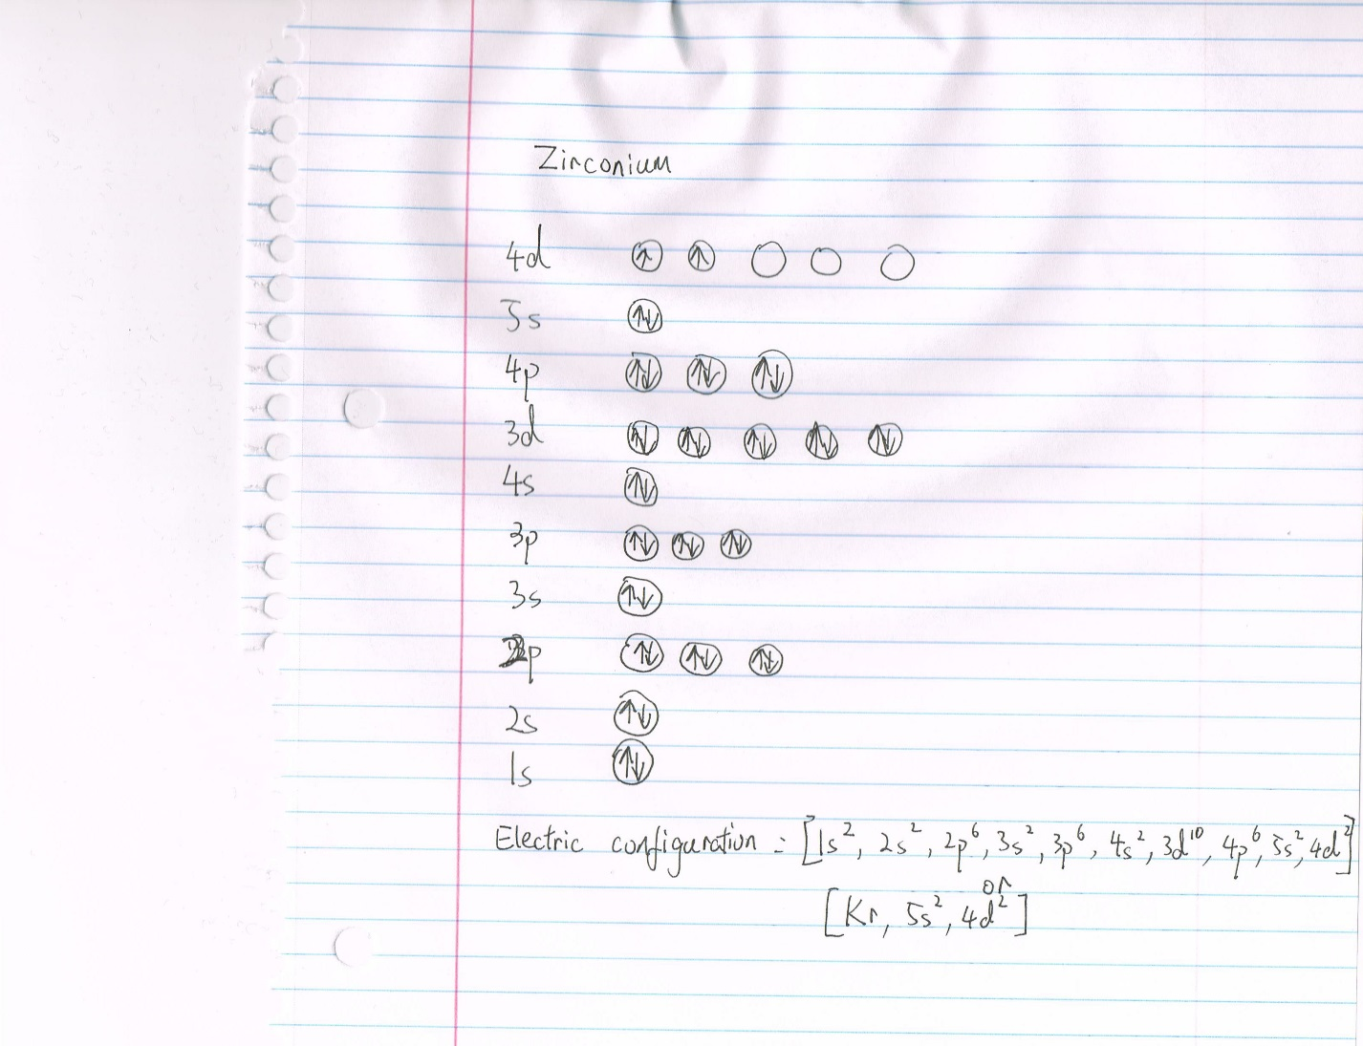

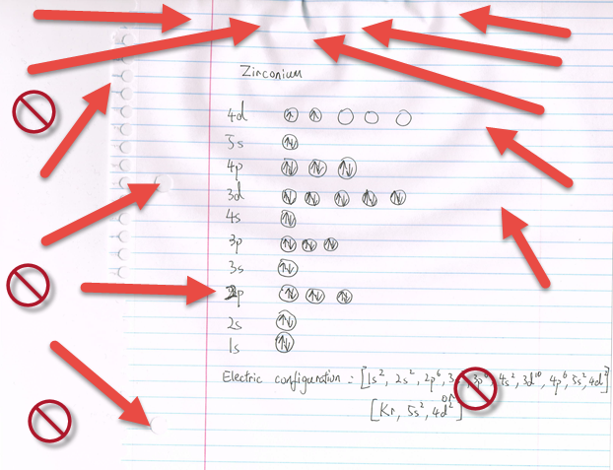

b. Use the diagram to explain why the ion exists.

In order to form , zirconium atom would have to lose 4 electrons. Once it loses 4 electrons, it reaches a stable state as the 4p orbital is filled. Thereore, is a stable ion and can exist

c. Compare the stability of the Zr atom and the Zr ion. Account for any differences in their stability.

Zr ion is more stable than Zr atom. Zr ion has its outer orbitals filled, which causes the ion to be chemically stable. On the other hand, the outer orbital of Zr atom is not completely filled, causing the atom to be chemically unstable.  
  
03 Zirconium

Energy Level Diagram 2 mx 🗶🗶 unacceptable … see below …

(Empty 4d orbitals for clarity)

Electronic Configuration 1 mk ✓🗶 This should be typed, not hand written and scanned. Please refer to your Submission Guidelines to read that scanned text will be returned unmarked.

Lose 4 e … Kr 2 mx ✓✓🗶

Filled outer shell 2 mx ✓✓

=== 4/7

For a good explanation of energy levels and orbitals ...

https://www.youtube.com/watch?v=cOlac8ruD_0  
  
Please crop your scans to show just your work.

Insert one scan or diagram per question or part of question.

Scan only diagrams or graphs, not text.

Be sure your diagrams are large enough for legibility and clarity.

Do not expect your reader to change the size of your pictures for you.

Do not include large blank or black spaces or the holes in your three ring paper or background pictures of your desk or your thumb or your legs or your pencil collection or your carpet or your wallpaper or your tablecloth or your pets or your pyjamas or your shorts.

Do not include the frame of the software that you used to create the diagram - unnecessary and distracting.

Do not include vast numbers of empty cells in a spreadsheet. Crop to the data for clarity.

Avoid glare and shadows.

Diagrams should be black on white, not dark grey on lighter grey.

Use a pen or sharp pencil (black), not a marker or crayon.

Do not allow pictures or writing to bleed through from the other side of the paper.

Do not make your diagrams on lined or wrinkled or dirty or folded paper.

If you are taking a picture, take it straight on, so your graphs etc. appear square on the page.

Insert all diagrams with the correct orientation - i.e. right side up!

Do not expect your reader to change the orientation of your pictures for you.

Do not include your own shadow or your dog's shadow.

Use a ruler where straight lines are required.

Use a compass or circle template where circles are required.

Be professional. Look professional.

1. Draw an orbital overlap diagram to represent the bonding in ammonia, 

04 Ammonia Overlap

Orbitals and electrons for N and H 2 mx ✓✓🗶 should be circles … see below …

Labels on orbitals 2 mx ✓✓

Overlaps 1 mk ✓🗶 ruler needed …

=== 4/5



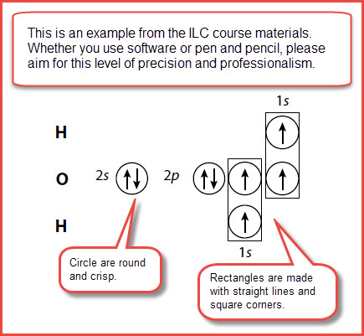  
  


1. Draw the Lewis structure and structural formula for:
   1. HCN  
        
      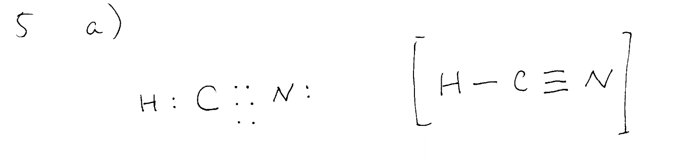
   2. 

05 Lewis and Structural

a. HCN Lewis 2 mx ✓✓🗶 e should be between the C and N …

HCN Structural 2 mx ✓✓🗶 no brackets needed …

b. SO3-2 Lewis 2 mx ✓🗶 Brackets and charge needed here.

SO3-2 Structural 2 mx ✓✓🗶 extra neg sign? Tidy brackets …

=== 5.5/8

For formal charge and resonant structure of the sulphite ion:

https://www.youtube.com/watch?v=JUt84_zUxck

1. Experimental evidence suggests that the nitrogen atom in ammonia, , has four identical orbitals in the shape of a pyramid or tetrahedron.
   1. Draw an energy-level diagram to show the formation of these hybrid orbitals.

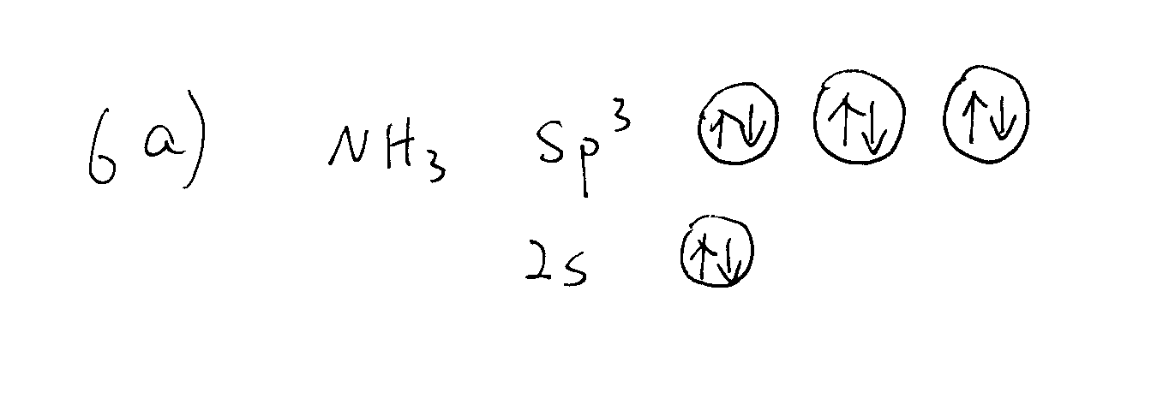

* 1. Name the type of hybrid orbitals found in . Of the four hybrid orbitals on the N atom, how many will take part in bonding? Explain.

The name of the type of orbital is orbital. Three of the four hybrid orbitals on the N atom will take part in bonding because there are three unfilled valent orbitals on the N atom, and 1 valent electrons on the three H atoms.

* 1. Draw for yourself the energy-level diagram showing the hybrid orbitals formed in the C atom when it bonds. Now look at those hybrid orbitals and those of the N atom and describe how the bonding with a N atom will differ with the bonding that occurs with a C atom, even though both atoms have four hybrid orbitals oriented in a tetrahedral shape.  
       
     

As illustrated in the diagrams an N atom does not promote electrons when forming hybrid orbital, which results in 3 pairable valence electrons and 1 lone pair. A C atom, promotes the electrons in its 2s orbital to 2p orbital when forming hybrid orbitals, and has 4 valence electrons ready to pair with other atoms. Despite having the same number of hybrid orbitals and bond shape, nitrogen and carbon bonds with different number of atoms.

The diagram shows that after hybridization, both the N atom and the C atom have four orbitals. However, due to the different numbers of electrons, the N atom only has three orbitals available for bonding, while the C atom has four. Therefore, the C atom will be able to bond with more atoms than N atom.  
  
06 Ammonia Tetrahedron

Hybridization Diagram

with correct energy levels 4 mx 🗶🗶🗶🗶 please review … See below ...

(The sp3 hybrid orbitals should be drawn at an energy level between the s and the p orbitals. The 1s orbitals should remain at the same energy level.)

sp3 hybrid orbitals 1 mk ✓

Three orbitals in bonding 1 mk ✓

Carbon four bonds / why 2 mx ✓✓

=== 4/8  
  
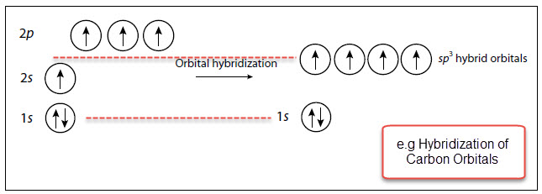

1. 1. Calculate the differences in electronegativity between the elements in each of these compounds.
   2. Predict whether each of these compounds would be an ionic or a molecular compound and justify each prediction.

would be an ionic compound since the difference of electronegativity is greater than 1.7

would be an ionic compound since the difference of electronegativity is greater than 1.7

would be a molecular compound since the difference of electronegativity is smaller than 1.7

* 1. Rank the bonds in these compounds in order of decreasing ionic character. Where do we always find compounds containing metals, in this ranking order?

|  |  |  |
| --- | --- | --- |
|  |  |  |
| 2.1 | 1.9 | 0.3 |

Compounds containing metals are more commonly found as ionic compounds, such as and   
  
✓ Good.

1. For the ion IO­3­-,
   1. Draw the electron dot diagram and structural formula using the method as taught in this course.



* 1. Predict the shape.

Trigonal Planar

* 1. Predict whether it is polar or non-polar and justify your prediction. Indicate the positive and negative poles

The difference of electronegativity between I and O is 0.8, which is between 0.4 and 1.7. Therefore, the molecular bond is polar covalent.

Positive pole: I atom

Negative pole: O atom  
  
08 Iodate Ion

a) Lewis dot 2 mx ✓🗶 Brackets and charge needed here. This is not the method taught in this course …

Structural 2 mx ✓🗶 🗶 extra neg sign? Shape needed … see below …

b) Pyramidal 1 mk 🗶

c) I pos/O neg/Expl’n 2 mx ✓✓

(justify prediction, indicate poles)

=== 3.5/7  
  
  
  
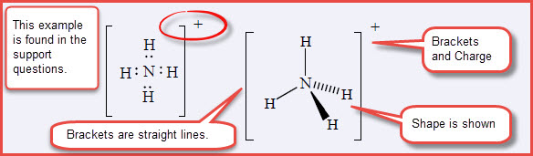

1. For the molecule CHCl3,
   1. Draw the electron dot diagram and structural formula. 
   2. Predict the shape.

Tetrahedral

* 1. Predict whether it is polar or non-polar and justify your prediction. Indicate the positive and negative poles.

The difference of electronegativity between C and H is 0.3, and 0.6 between C and Cl. Therefore, the molecular bond is polar covalent.

Positive pole: H atom

Negative pole: Cl atom  
  
09 Chloroform Structure

a) Lewis Dot 2 mx ✓✓🗶 closer together to clarify sharing of e …

Structural 2 mx 🗶🗶 no brackets … shape needed …

b) Tetrahedral 1 mk 🗶 wrong diagrams here … not sulphite …

c) H pos/Cl neg/expl’n 2 mx ✓✓

(justify prediction, indicate poles)

=== 3.5/7

1. The molecular shapes of water and methane are based on ­­­sp3 hybrid orbitals attached to the central atoms. Why are the bond angles in these molecules not identical?

The difference between the bond angles of water and methane molecular shapes is due to the presence of lone pairs in water molecules (H2O). Since lone pairs create more repulsion than bonded pairs, the degree of H atom’s bond angles is decreased, resulting in a bent shape. On the other hand, methane(CH4) does not have lone pairs, and the bond angle of all orbitals are equal, resulting in a tetrahedral shape.  
  
✓ Good.

1. Imagine that you are the owner of a small dry-cleaning business that is considering switching from using the “normal” organic solvents to liquid carbon dioxide, as described in the lesson introduction.
   1. Provide a brief explanation of why carbon dioxide is a suitable solvent to use.

Carbon dioxide (CO2) is non-polar molecule, with no net molecular dipole. This attribute can be found on many common substances such as oil and fat, which consists of non-polar molecules. Because substances of similar polarity tend to dissolve in each other, liquid carbon dioxide can be very effective at dissolving oil and grease off fabrics.

* 1. Research two pros and two cons of using liquid carbon dioxide for dry-cleaning.

Pros: 1. less toxic and flammable compared to standard organic solvents.

2. Highly reusable and can be reused for many cycles. Reduces economic cost

Cons: 1. More expensive to purchase than conventional organic solvents.

2. Increased CO2 released to the environment, resulting in more greenhouse gas presence in the environment.  
  
✓

1. Consider the following boiling point data for these halogen molecules.
   1. Explain the trend in the boiling points of the halogens by describing the intermolecular forces present

The only intermolecular forces present is London force. This force is the result of temporary dipoles formed by moving electrons. Therefore, the more electrons present in molecules, the strong their attraction force is, resulting in higher boiling points.

* 1. Plot a graph of boiling point against the number of electrons. What force is directly related to number of electrons?

London force is directly related to number of electrons.

* 1. Use your graph to predict the boiling point of astatine, the remaining member of the halogen family.

Since astatine possesses the largest number of electrons in the halogen family, it would also have the highest boiling point, estimating 320 degrees Celsius.  
  
12 Halogens BP

Discussion of London Forces 3 mx ✓✓✓ good concise answer!

Please be sure to explain WHY the

London forces increase as the number

of protons and electrons increase.

(Van der Waal Forces is too general a term)

Please discuss INTERmolecular forces

keeping the molecules together as a liquid.

Graph 3 mx ✓🗶🗶 Title needed, axis labels and units …

Number of e / London Forces 1 mk ✓

Extrapolation / Prediction 1 mk 🗶

(Curve of Best Fit)

=== 5/8

Note that the question asks you to use your graph to predict the BP of Astatine. Your graph does not allow this extrapolation/prediction. If you make your graph larger to include 170 electrons, you will be able to extrapolate and see your prediction as a point and assign a value.

1. The molar masses and boiling points of two carbon compounds are given in the following table. Why is there such a large difference between them in boiling point, despite their similarity in molar mass? (Hint: Set up a page with columns as was done in the first set of Support Questions in Lesson 4.)

|  |  |  |  |
| --- | --- | --- | --- |
| Formula | Dipole-dipole forces | London Forces | Total Forces |
| C2H6 | Non-polar | 18e/18p | Extremely weak forces |
| CH3OH | Polar, dipole-dipole force present | 18e/18p | Stronger total forces |

As illustrated above, although both compounds have approximately same amount of London forces, their difference in bonding polarity makes their intermolecular force very different. Since CH3OH has dipole-dipole force present, its total intermolecular force is much greater than that of C2H6. Therefore, CH3OH has a much higher boiling point.  
  
13 Ethane Methanol BP

Methanol is polar, ethane is non-polar 1 mk ✓

Ethane has only London forces 1 mk ✓

Methanol has hydrogen bonding, stronger 1 mk 🗶 missing

=== 2/3

1. A) Research the space elevator concept. Consider the environment in which the cable must operate. Recommend two physical, and one chemical property that the cable should have. Justify your choices.

Physical property： 1. Strength: the material must have the tensile strength to support not only its own weight, but the weight of the load as well. Since space elevator stretches up to thousands of meters, the material used to support the structure must be able to withstand tremendous amount of pressure.

2. Weight: For a massive object such as the space elevator, the weight of the material will have a profound effect on the durability and economic cost of the building. Light weight material will exact less stress on the building’s stability, as well as the cost of constuction and maintenance

Chemical property: Space is filled with dangerous cosmic radiation. Humans are only protected inside the atmospheres. A ride on the space elevator would venture well outside the protection of the atmosphere, and risk exposure to radiation. Therefore, the material of the space elevator should be able to absorb most, if not all of the radiation that could potentially harm space travelers.

B) Based on what you have learned about bonding and forces in solids, which type of solid, in your opinion, is the most suitable for use in the space elevator cable? Justify your choices.

Based on the physical and chemical qualities demanded, solids in the covalent network solids type would be most ideal for using as construction material. For instance, carbon nanotubes, a type of such solids, have outstanding qualities of strength and lightness, and has been an ideal building material for the aerospace industry.  
  
14 Space Elevator

Two physical properties and justifications

(strong, elastic, solid, high MP, flexible,

conduct electricity for lightning strikes

(The CN Tower is a huge lightning rod),

no melting or burning, lightweight)

Physical property & justification 2 mx ✓✓

Physical property & justification 2 mx ✓✓

One chemical property & justification 2 mx 🗶🗶 Please discuss the properties of the cable, not the climber …

(resistant to corrosion or oxidization,

chemically inert, no oxide layer,

chemically stable when heated or cooled)

Best solid 1 mk ✓

Justification 2 mx ✓✓

=== 7/9

http://www.understandingnano.com/nanotubes-carbon-properties.html

https://en.wikipedia.org/wiki/Space_elevator

Physical Properties:

http://chemistry.elmhurst.edu/vchembook/104Aphysprop.html

Carbon nanotubes conduct electricity:

https://www.sciencedaily.com/releases/2009/03/090320134041.htm

Examples of metallic solids include, copper, gold, zinc, .... We tend to think about metallic solids as pure metals, but they can also be combinations of metals like bronze, which is a mixture of copper and tin ...

https://ch301.cm.utexas.edu/section2.php?target=imfs/solids/metallic-solids.html

https://www.google.ca/search?q=diamond+for+the+space+elevator&ie=utf-8&oe=utf-8&client=firefox-b-ab&gfe_rd=cr&dcr=0&ei=yqNrWrXuFcj_8AeKvb4Q

A chemical reaction occurs when chemical bonds are built or broken. A chemical property would predict what happens when changes are made to the bonds. The existing bonds were made in a previous chemical reaction and cannot now be called a chemical property.

https://en.wikipedia.org/wiki/Chemical_property

Note that the question does not refer to the lunar space elevator.

https://en.wikipedia.org/wiki/Lunar_space_elevator